Jennifer Anderson
Reviewed July 2026
Next Review: July 2027

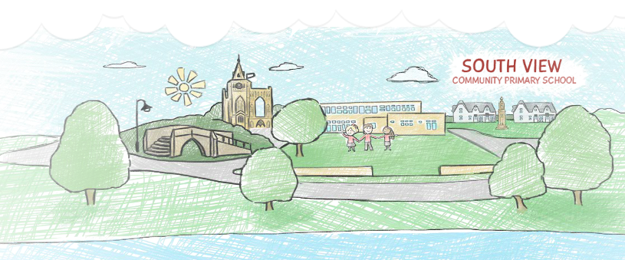
South View Community Primary School

Our Religious Education (RE) Curriculum

Contents

1. THE BASIC PRINCIPLES OF OUR CURRICULUM PAGE 3
2. OUR CURRICULUM INTENT 3
3. ASSESSMENT FOR LEARNING 4
4. RE INTENT 5
5. RE IMPLEMENTATION 6
6. RE IMPACT 7
7. MEETING THE NEEDS OF ALL CHILDREN IN RE 8
8. RE LONG TERM PLAN 10
9. RE PROGRESSION OVERVIEW 13

THE BASIC PRINCIPLES OF OUR CURRICULUM

Learning is a change to long term memory.
Our aims are to ensure that our children experience a wide breadth of study and have, by the end of each Key Stage, long-term memory of an ambitious body of procedural and semantic knowledge.

OUR CURRICULUM INTENT
Curriculum Drivers shape our curriculum breadth. They are derived from an exploration of the backgrounds of our children, our beliefs about high quality education and our values. They are used to ensure we give our children appropriate and ambitious curriculum opportunities. Our curriculum drivers, enabling us to ensure OUR children get what THEY need from us are that:
- Our children will develop vocabulary so that they are able to speak and understand spoken language, access more complex texts and write with eloquence.
- Our children will leave South View as successful readers. They will 'learn to read' and consequently 'read to learn'.
- Our children will explore their own cultures, surroundings and emotions and those of others, to gain a wider understanding of the world and their place within it.

3. ASSESSMENT FOR LEARNING
All teachers assess the class against the progression documents for the relevant subjects. This is shared with subject leaders so they are aware of areas for further development.

In RE we assess children based on their enquiry question for their unit. This assessment is used to check both factual knowledge and children’s application of that to the world around them. Teachers use both a summative assessment (based on end of unit assessments) as well as formative teacher assessment throughout the unit.

4. RE INTENT
Key Strand: Curriculum – Intent. Does our Religious Education curriculum inspire?

- To deliver a deeper understanding of different religions and beliefs (following the Lincolnshire Agreed Syllabus for RE (LAS:RE) resulting in greater tolerance, understanding and respect that allow them to appreciate all religions and beliefs, and those who practice them, now and in the future.
- To provide children with the key knowledge and vocabulary related to a range of different religions and beliefs.
- To have an enquiry-based approach; to encourage children to want to ask questions; to read (appropriate) religious or belief-based texts; to be self-led in finding answers and relating those answers to help form their own beliefs and develop a sense of awe, wonder and mystery.
- To provoke challenging questions about the meaning and purpose of life, beliefs, the self, and issues of right and wrong, commitment and belonging, fostering personal reflection and spiritual development.
- To encourage children to explore their own beliefs (religious or non-religious) in the light of what they learn, as they examine issues of religious belief and faith and how these impact on personal, institutional and social ethics.
- To enable children to build their sense of identity and belonging, which helps them flourish within their communities and as citizens in a diverse society.

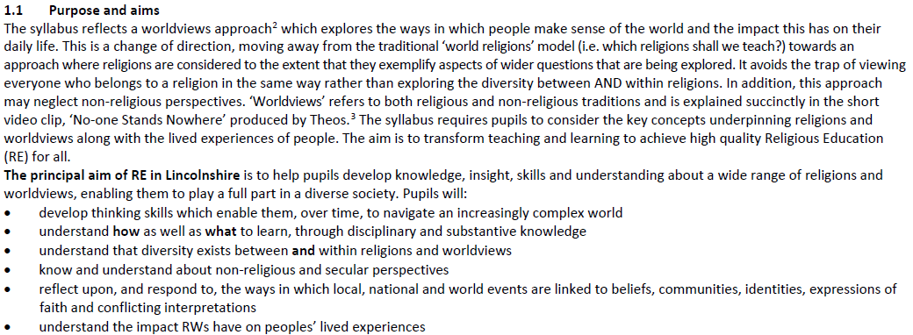

5. RE IMPLEMENTATION

At South View Community Primary School, we follow the Lincolnshire Agreed Syllabus. Our curriculum is taught weekly to ensure that children revisit key learning regularly which enables them to build upon prior knowledge and develop a good understanding of different religions, aiding them in developing their own beliefs and spirituality.
In Foundation Stage, children begin by focusing on the building blocks of RE focusing on the Theme: Special and Sacred. They will focus on the religions Christianity and Hinduism and explore this theme through stories, celebrations and places.
In Key Stage One, children continue their learning by following the theme special and sacred stories in Year 1 and sacred texts, beliefs and connections in Year 2. They will explore Christianity, Judaism, Islam and Hinduism over this key stage.
In Lower Key Stage Two, children build further upon their learning from Key Stage One by exploring the theme why communities matter and commitment, promises and meaning. They will continue building upon their understanding of Christianity, Islam and Judaism as well as exploring Sikhi and Buddhism. Children will also make links to the world view humanism.
In Upper Key Stage Two children will look at expression, experience and senses and in Year 6 conclude their learning by focusing on big questions.
Our curriculum and units have been planned and sequenced so that prior learning is built upon and children make links within and between different religions and world viewpoints.
Children use different skills to deepen their understanding and the knowledge taught: investigating, reflecting, recalling and retelling, exploring, discussing and empathising so that children can discuss and compare the lives of people they have studied from a variety of different religions.
At South View, children are also involved in class and whole school assemblies to further develop their understanding of different religions and develop respect and tolerance of different beliefs and cultures.
Visits to local places of worship, visitors from different religions to our school and themed days also enrich the curriculum at our school.

6.RE IMPACT

Our children make progress by knowing more and remembering more which enables them to make links between different religions and develop their own sense of belief.
At South View the impact of our RE curriculum can be measured by:

- Children showing respectful behaviour to all within our school setting and outside of school in the wider community and beyond.
- Children demonstrating a positive attitude towards people of any religion and showing an understanding of cultural beliefs different to their own.
- Assessing children’s understanding of each unit’s key enquiry question at the end of each unit.
- Images and videos of the children’s learning.
- Marking of written work in books.
- Interviewing the pupils about their learning (pupil voice).
- Exploring children’s RE journals and their learning journey within.

7. MEETING THE NEEDS OF ALL CHILDREN IN RE
Supporting Children with Special Educational Needs and Disabilities
Cognition and Learning |  | Communication and Interaction
Subject Challenges for SEND | Provision for SEND | Subject Challenges for SEND | Provision for SEND
Conceptual understanding of key historical and modern-day religious practices  Low attainment in literacy can present barriers to activities e.g. understanding of subject specific vocabulary, ability to read key information | - Use of simplified visual activities to support children’s understanding.  - Use of simplified, dual coded resources such as the knowledge organisers. Potentially additional support during lessons.  - Differentiate to provide shorter, simplified texts/information  - Teacher / TA support for children during lessons to access learning.  - Use of writing frames to support children access activities. | Language/communication difficulties may make it difficult for children to participate in activities and access learning.  Difficulties with processing language. | - Teacher / TA support for children during lessons to access learning.  - Opportunities for retrieval to reinforce learning, through accessible low stakes assessment each week.  - Alternative ways to present/access work e.g. through technology  - Simplified step by step instructions, visuals and mixed ability pairs.
Physical and Sensory |  | Social Emotional and Mental Health
Subject Challenges for SEND | Provision for SEND | Subject Challenges for SEND | Provision for SEND
Children with sensory impairments may find it difficult to access physical resources  Children with visual or auditory impairment may have related challenges to accessing lessons.  Accessibility/participation in particular activities may be impacted by physical disabilities | - Use of technology to support access e.g. videos  - Ensure seating arrangements are carefully considered, ensure labels are used for those with auditory difficulties. Use of audio descriptions for visuals e.g. artefacts  - Ensure those with PD are considered at the planning stage – how can staff ensure full inclusion? | If children believe they cannot be successful in class they may become frustrated and withdrawn – low self-esteem etc  Children may find certain topics within RE difficult or triggering e.g. loss, death etc. | - Adapt lessons appropriately with clear instruction, scaffolding and differentiation accordingly, to ensure lessons are accessible.  - Ensure content being used in lesson is not overly distressing for any children in class. Allow children to have a safe space to express these feelings if they wish.

Non-Negotiables that need to be in place in all lessons/classrooms when teaching RE:
- Provide access to physical resources such as real-life objects from different religions where appropriate to support children with SEN to access learning
- Access to dual coded resources/knowledge organisers to support understanding of key vocabulary
- Ensure each lesson has an opportunity for class or group discussions so children can share their views/understanding verbally

8. RE LONG TERM PLAN
EYFS | Theme: Special and Sacred
EYFS | Autumn Term |  | Spring Term |  | Summer Term
 | Key Question: Which people, stories and events are special to me?  Compulsory Religions: Christianity, Hinduism |  | Key Question: What do I know about Easter and Holi?  Compulsory Religions: Christianity, Hinduism |  | Key Question: Why are some places and objects special or sacred?  Compulsory Religions: Christianity, Hinduism
Yr1 | Theme: Special and Sacred Stories
Yr1 | Autumn Term 1 | Autumn Term 2 | Spring Term |  | Summer Term
 | Key Question: What do stories from religious traditions teach about God?  What can we learn from other stories?  Compulsory Religions: Abrahamic religions- Christianity, Judaism | Key Question: How are stories and celebrations linked?  Compulsory Religions: Abrahamic religions- Christianity, Judaism | Key Question: What do creation stories teach people about God and human nature?  Compulsory Religions: Abrahamic religions- Christianity, Judaism, Islam, Humanism |  | Key Question: What do people learn from stories and festivals?  Compulsory Religions: Abrahamic religions- Christianity, Islam, Judaism
Yr2 | Theme: Sacred Texts, Beliefs and Connections
Yr2 | Autumn Term |  | Spring and Summer Term
 | Key Question: What are sacred texts and why do they matter?  Compulsory Religions: Abrahamic religion Christianity and Islam  Dharmic religion:, Hinduism |  | Key Question: What do we mean by religion and worldviews?  What beliefs, values and practices are important in religions and worldviews?  Compulsory Religions: Abrahamic religion- Christianity and Islam  Dharmic religion: Hinduism
Yr3 | Theme: Why Communities Matter
Yr3 | Autumn Term |  | Spring Term |  | Summer Term
 | Key Question: What does pilgrimage mean to individuals and communities?  Compulsory Religions: Christianity  Choice of Abrahamic religion: Islam  Dharmic religion: Hinduism |  | Key Question: Which Religious and Worldview communities can we find in our neighbourhood?  Compulsory Religions N/A:  Religions in our community: Christianity, Islam, Sikhi, Judaism,Hinduism, Buddhism |  | School Designed Unit: How do we decide what’s right or wrong?  Compulsory Religions: Christianity, Judaism, Islam,  Dharmic Religion: Hinduism, Buddhism
Yr4 | Theme: Commitment, Promises and Meaning
Yr4 | Autumn Term |  | Spring Term | Summer Term
Yr4 | Key Question: How do people welcome new life into the world?  How do people show their commitment to a religion?  Compulsory Religions: Christianity  Choice of Abrahamic religion: Islam  Choice of Dharmic religion: Sikhi  Links to Humanism |  | Key Question: How do people celebrate marriage?  Compulsory Religions: Christianity  Choice of Abrahamic religion: Islam  Choice of Dharmic religion: Sikhi  Links to Humanism |  | Key Question: What do people believe about the afterlife?  How is this expressed in funeral practices?  Compulsory Religions: Christianity  Choice of Abrahamic religion: Islam  Choice of Dharmic religion: Sikhi  Links to Humanism
Yr5 | Theme: Expression, Experience and the Senses
Yr5 | Autumn Term |  | Spring Term |  | Summer Term
 | Key Question: How do people express their beliefs through worship and caring for others?  How do people use their senses in worship?  Compulsory Religions: Christianity  Choice of Abrahamic religion: Islam  Choice of Dharmic religion: Hinduism |  | Key Question: What do we mean by religious and spiritual experiences?  Compulsory Religions: Christianity  Choice of Abrahamic religion: Islam  Choice of Dharmic religion: Hinduism |  | School Designed Unit: Inspirational Women  Christianity, Islam, Judaism  Hinduism
Yr6 | Theme: Big Questions: What Do People Believe?
Yr6 | Autumn and Spring Term |  |  |  | Summer Term
 | Key Questions: How do people know who or what to believe?  What do people believe about the existence of God?  What do people believe about good, evil and suffering?  How do people choose between right and wrong?  What do people believe about caring for the world and others?  What do people believe about peace?  Compulsory Religions: Christianity  A balance of other Abrahamic and Dharmic religions  Humanism |  |  |  | Key Question: What is my religion or worldview?

9. RE PROGRESSION OVERVIEW
R.E.
South View Primary School

Foundation Stage | Progression Strands | Year 1 | Year 2 |  | Year 3 | Year 4 |  | Year 5 | Year 6
(Understanding of the World) |  | Key Stage One |  |  | Lower Key Stage Two |  |  | Upper Key Stage Two
-Talk about members of their immediate family and community.  -Name and describe people who are familiar to them.  -Comment on images of familiar situations in the past.  -Compare and contrast characters from stories, including  figures from the past.  -Recognise that people have different beliefs and celebrate  special times in different ways.  -Recognise some similarities and differences between life in this country and life in other countries.  -Understand the effect of changing seasons on the natural world around them. | Strand A: Belonging, Identity and Community. | How stories of all kinds give communities a shared identity.  The ways in which festivals and celebrations bring people together through a sense of belonging. |  | How religions and worldviews connect people, e.g. to families, local and national communities, globally.  How sacred scriptures are used in worship and ceremonies to bring communities together.  How worldviews connect with each other. | Why pilgrimage has special meaning for communities.  How going on a pilgrimage can strengthen a person’s religious identity.  What it means to a person to be part of local RW communities.  How there is diversity within the same RW community.  What RWs contribute to the wider community.  How communities are represented in school and in the neighbourhood. |  | How different ceremonies marking important steps in life bring communities together, symbolising a sense of belonging and identity.  How clothing and symbols contribute to a sense of identity.  How promises made are strengthened by the presence of the community. | How worship brings communities together and makes individuals feel that they belong.  How religious or spiritual experiences can be shared by a community.  How people within Abrahamic and Dharmic traditions express worship.  How people care for those in their own communities and for others. | How beliefs are linked to a sense of identity.  How communities come together to care for the planet, work for peace.
 | Strand B: Beliefs, Influences and Values | How stories form part of religious and non-religious beliefs and help people understand the world.  What stories from the Bible teach people about God and the way they should lead their lives.  How stories relating to key festivals reflect religious beliefs and concepts, e.g. Christmas and Incarnation.  Why Easter is so important to Christians.  Why Passover is so important to Jews. |  | What people in different RWs believe about revelation and sacred scriptures.  What people from Abrahamic and Dharmic traditions hold as key beliefs.  What humanists believe.  What shared beliefs exist within and between worldviews. | How pilgrimage reflects key beliefs, e.g. Makkah and the 5 Pillars of Islam.  What values hold communities together.  How people may belong to more than one RW community. |  | How promises made in commitment ceremonies strengthen belief.  How ceremonies reflect key beliefs about the purpose of life and death.  How promises are connected to beliefs about death. | How worship reflects key beliefs.  The ways in which beliefs and actions (in worship) are linked.  How religious or spiritual experiences may strengthen a person’s belief. | How different types of authority and influence determine people’s beliefs and actions.  How values are reflected in the lives of inspirational people.  What religious and philosophical thinkers say about the existence of God.  What people believe about good and evil and how this may or may not be linked to religion.  How people decide about right and wrong.  How people believe they should treat each other and the world around them.  How key thinkers and activists have influenced the peace narrative.
 | Strand C: Expression, Experience and the Sacred | How stories inform what happens during festivals, e.g. lighting candles at Hanukkah.  How stories are used as part of observance of festivals, e.g. telling the story of the Exodus at Passover.  How some stories are considered to be special and/or sacred. |  | Why some texts are considered to be sacred.  How sacred texts are used in personal and communal worship and other ceremonies.  How people show respect for sacred scriptures. | What people experience during pilgrimages and how this might be life changing.  What religious and non-religious pilgrimages have in common.  What actions and rituals take place during pilgrimages.  How communities in Lincolnshire express their faith in everyday life and at special times. |  | What rituals and symbolism characterise ceremonies.  How the sacred is a key component of religious ceremonies, e.g. promises made to God. | How people express their faith through prayer and worship, both as members of communities, families and individuals.  How music, art and literature might enhance worship.  Why experiencing the sacred and holy matters in worship and ceremonies.  Which symbols, objects and artefacts aid worship.  The ways in which sensory and emotional responses form part of worship and religious experience.  How people express care for others, based on teaching within RWs.  The ways in which people encounter the sacred or ‘unexplained’ through religious and spiritual experiences. | How people express ‘big questions’ in everyday life.  How inspiration may have a religious or non-religious source.  How people express their beliefs in the way they behave and through the values they hold, e.g. about the environment.
 | Strand D: Truth, Interpretation and Meaning. | How stories can mean different things to different people.  How different stories may contain ‘truth’ and what this means to different people.  Why people have different views about how the world began. |  | What believers mean by ‘truth’ in sacred scriptures and how this can be interpreted in different ways.  Why the concept of revelation is central to understanding some sacred scriptures. | Why the experience of pilgrimage may have a different meaning for people.  How communities in an area change over time.  Why belonging to a community matters to people. |  | How people interpret the meaning of life and death.  How commitment ceremonies may have different meanings for different people. | What people from different Abrahamic and Dharmic traditions mean by worship, prayer and meditation.  How beliefs and ideas can be demonstrated and understood in different ways, including through experiences.  How religious/spiritual experiences such as miracles can be interpreted in different ways.  How non-religious people might interpret religious experiences. | Why some sources of truth are trusted more than others.  How influence and authority may be interpreted in different ways.  Why people do not always agree on what makes a person inspirational.  How beliefs about the existence of God are open to interpretation and may change over time.  How people decide what is good or bad, right or wrong.  How ‘peace’ can be interpreted in different ways.

Foundation Stage  (Understanding the world) | Year 1 | Year 2 | Year 3 | Year 4 | Year 5 | Year 6Ye  6

10.GENERAL RE VOCABULARY

