
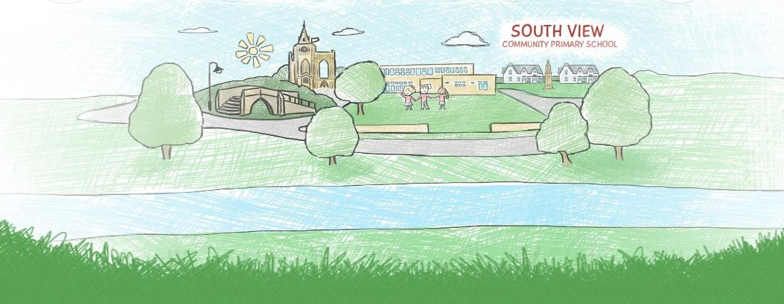





South View Community Primary School

Parent Code of Conduct
Last reviewed: September 2024
Reviewed by: Standards/FGB
Next review due: October 2026
Advisory
School Policy
PARENTS AND CARERS CODE OF CONDUCT

Introduction
We are very fortunate to have mainly supportive and friendly parents/carers. We want our parents to recognise that educating children is a process that involves partnership between parents, class teachers and the school community.
As a partnership, our parents/carers should understand the importance of a good working relationship to equip children with the necessary skills for adulthood. For these reasons we continue to welcome and encourage parents/carers to participate fully in the life of our school.
Parental engagement with their children's learning is important in supporting attainment and progress and parents have a legitimate right to understand what their child is learning at school.
However, contact between parents/carers and the school must be appropriate proportionate and respectful, both of the professional knowledge, experience and skill of teaching and senior staff at the school and of the entitlement of staff at the school to some work/life balance.

Purpose
The purpose of this policy is to provide a reminder to all parents, carers and visitors to our school about the expected conduct. This is so we can continue to flourish. progress and achieve in an atmosphere of mutual understanding.
The policy sets out:
- The general principles underpinning the conduct of members of the school community.
- How it is expected that communication between parents/carers and the school will take place.
- What behaviour towards the school and members of the school community are deemed unacceptable and open to challenge by the school.
- The additional steps the school can take in respect of unacceptable behaviour by a parent or carer.
General Principles
- Remember that the school is governed by the school rules as decided upon by the Governing Body of the school and the Senior Leadership Team.
- Respect the caring ethos and values of our school;
- Understand that both teachers and parents need to work together for the benefit of their children;
- Demonstrate that all members of the school community should be treated with respect and therefore set a good example in their own speech and behaviour;

Communication
There are many reasons you might want to communicate with the school or a member of staff at the school. This could be simply phoning in to report a child's absence or just informing the member of staff at the gate when you drop your child off that they have forgotten their PE kit or have been complaining of feeling a little unwell. These short conversations to impart information are entirely necessary.
However please remember:
- How busy members of staff are during the school day, particularly first thing in the morning and where you need to speak with a member of staff make an appointment to do so at a time when they can give you their full attention.
- Approach the school to help resolve any issues of concern by making an appointment to meet with the class teacher in the first instance. In the second instance you would speak with the teacher’s line manager, which in our school is the head teacher.
- If the matter is still not resolved follow the procedure in the school's Complaints Policy which is available under the heading "policies" on our website.
- If you wish to correspond by email this should be done through the school's central email address at enquiries@southview.lincs.sch.uk This address is monitored regularly during the school day and emails forwarded to the appropriate member of staff or Governor.
- Ensure that all such communications are polite and that you are always mindful of the right of the recipient to be treated with respect.
- When meeting face to face with members of staff to discuss any matters concerning your child's education or wellbeing in school, approach the matter calmly and politely, as this will also ensure progress can be made to address any issues or concerns. Remember that if you wish to speak with a member of staff it will normally fall to you to make a mutually convenient appointment.
Unacceptable Behaviour:
- Contacting staff or members of the Governing Body out of school hours using their individual email addresses rather than the school contact email address above. Staff and Governors are entitled to their own personal and family time.
- Do not send any form of correspondence to members of staff or Governors at the school demanding an immediate response or a response within your own time frame as the matter will be addressed, where appropriate, in a time frame deemed appropriate by the recipient.
- Send lengthy, frequent, demanding, or disrespectful emails to staff members as this will seriously undermine their ability to carry out their core role of educating the children in their care.
- When corresponding or speaking with staff in person do not use language that calls in to question their professional abilities or represents any form of personal attack or seek to direct how they carry out their professional roles or run the school. The running of the school is a matter for the Senior Leadership Team and the Governing Body of the school.
- It is unacceptable to record telephone conversations with staff members or to record meetings with staff and/or Governors at the school without making them aware you are doing it and seeking their express permission to capture what could be their personal information and breach their human right to privacy which extends to their workplace.
- Resort to any other form of criticism of the school, its staff or Governing Body or any other matters that relate directly to the school via a medium other than the schools complaints policy and parents and carers are asked to be aware of the schools "social media policy" as it appears in "Appendix A".
- When speaking with a staff member or any other member of the school community whether in person, on the telephone or by any other means of communication it is entirely inappropriate to raise your voice, invade their personal space, use language that is disrespectful, rude, offensive, aggressive or threatening.
- Do not shout, swear or cause any form of disruption on school grounds.
- Any threats of violence or use of violence towards anyone on school premises is a criminal offence as is damage to school premises and will be likely to result in the matter being reported to the police.
- Do not smoke or consume alcohol or other drugs on any part of the school premises.
- Do not bring dogs onto the school premises unless already agreed with the school that the dog is a guide dog or other form of assistance dog and consent has been given for the presence of the dog to assist its owner on school premises.
- Avoid using staff as threats to reprimand children’s behaviour;
- Approaching someone else’s child in order to discuss or chastise them because of the actions of this child towards their own child. (Such an approach to a child may be seen to be an assault on that child and may have legal consequences).
- Do not use disruptive behaviour which interferes or threatens to interfere with the operation of a classroom, an employee’s office, office area or any other area of the school grounds including team matches;

Additional Steps by the school:
- The member of staff or Governor concerned may challenge the behaviour by asking the person concerned to respect their personal space, stop shouting or using inappropriate behaviour or may end an unacceptable phone call or ask you to leave the school.
- The school may correspond in writing with a parent or carer to challenge behaviour that the school is finding unacceptable such as, for example, being rude to a member of staff or sending too many emails making demands of the school.
- If the school decide the matter requires a more formal approach, the school may instruct its legal advisers to write to the parent or carer warning them about their behaviour and/or putting in place a communications strategy to restrict their means of corresponding with the school and/or banning them from school premises if felt to be appropriate.
- Clearly in serious instances where the peace is breached or the criminal law broken the school will also involve the police.
Please note that school premises are not public places but private premises and you have an implied right to enter the school as a parent or carer of a child at the school but it is open to the school to remove that right of entry at any time it deems this to be necessary.
We trust that parents and carers will assist our school with the implementation of this policy and we thank you for your continuing support of the school.
Note: Could parents please ensure they make all persons responsible for collecting their children aware of this policy.

Appendix 1: Inappropriate use of Social Network Site

Social media websites are being used increasingly to fuel campaigns and complaints against schools, Head Teachers, school staff, and in some cases other parents/pupils.
The school seeks to teach pupils the importance of appropriate and responsible use of social media and it is therefore vital that everyone in the school community, including parents and carers lead by example.

The Governors considers the use of social media websites to complain about the school or individual members of staff or make personal comments about anyone in the school community is unacceptable and not in the best interests of the children or the whole school community. Any concerns you may have must be made through the appropriate channels using the Schools Complaints Policy by speaking to the class teacher, the Head Teacher or the Chair of Governors, so they can be dealt with fairly, appropriately and effectively for all concerned in line with that policy.
In the event that any student or parent/carer of a child/ren being educated in the school is found to be posting libelous or defamatory comments on Facebook or other social network sites, they will be reported to the appropriate 'report abuse' section of the network site.

All social network sites have clear rules about the content, which can be posted, on the site and they provide robust mechanisms to report contact or activity which breaches this. The school will also expect that any parent/carer or student removes such comments immediately.

In serious cases the school will also consider its legal options to deal with any such misuse of social networking and other sites. Additionally, and perhaps more importantly is the issue of cyber bullying and the use by one child or a parent to publicly humiliate another by inappropriate social network entry. We will take and deal with this as a serious incident of school bullying. Thankfully such incidents are extremely rare.

Please note that the inappropriate use of a communications network can give rise to offences under the Malicious Communications Act 1988 or the Communications Act 2003 and if persistent could be deemed to constitute the offence of harassment.

